**1.What are the two values of the Boolean data type? How do you write them?**

True

False

- They are written as

- boolA =True

- boolB = False

**2. What are the three different types of Boolean operators?**

1. and
2. or
3. not

**3. Make a list of each Boolean operator's truth tables (i.e. every possible combination of Boolean values for the operator and what it evaluate ).**

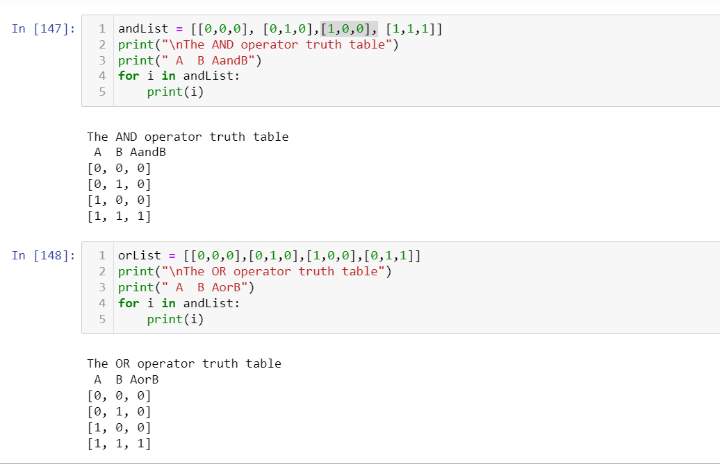

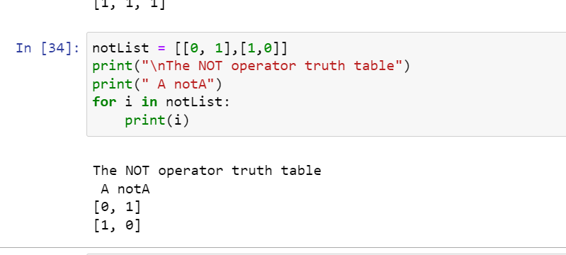

**4. What are the values of the following expressions?**

**(5 > 4) and (3 == 5)**

**not (5 > 4)**

**(5 > 4) or (3 == 5)**

**not ((5 > 4) or (3 == 5))**

**(True and True) and (True == False)**

**(not False) or (not True)**

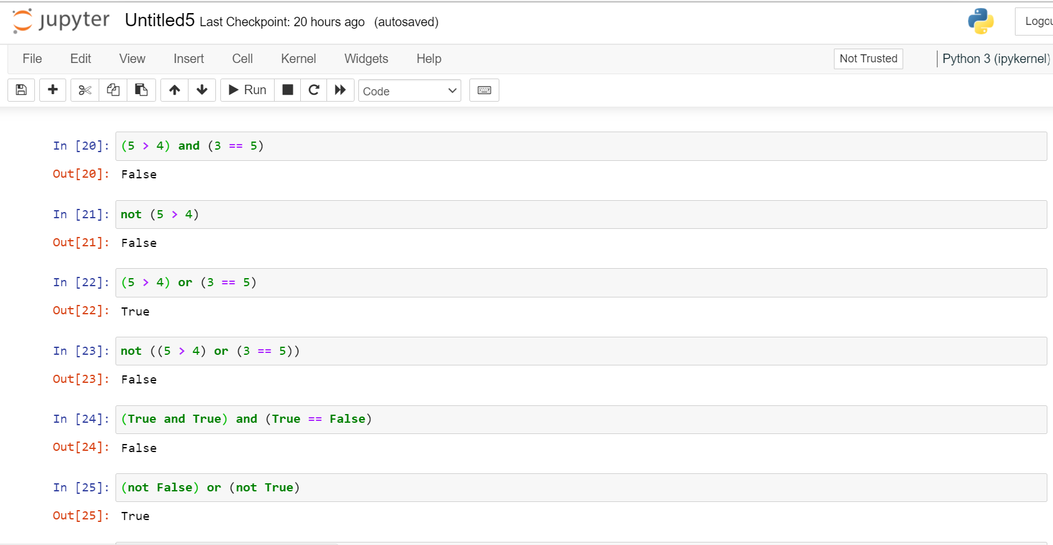

**5. What are the six comparison operators?**

1. == -> Equal
2. != -> Not equal
3. > -> Greater than
4. < -> Less than
5. >= -> Greater than or equal to
6. <= -> Less than or equal to

**6. How do you tell the difference between the equal to and assignment operators? Describe a condition and when you would use one.**

Assignment operator "=" : It is used for assigning the value to a variable.

Equal to Operator "==" : It s a relational or comparison operator. It's used for comparing two values. It returns either 0 or 1 depending on the values on the both sides of operator.

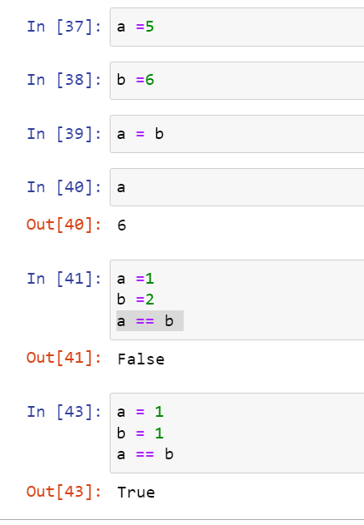

**7. Identify the three blocks in this code:**

**spam = 0**

**if spam == 10:**

**print('eggs')**

**if spam > 5:**

**print('bacon')**

**else:**

**print('ham')**

**print('spam')**

**print('spam')**

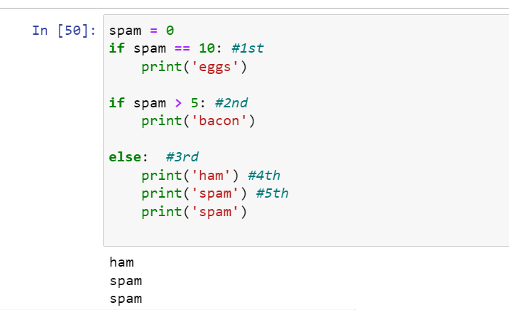

**8. Write code that prints Hello if 1 is stored in spam, prints Howdy if 2 is stored in spam, and prints Greetings! if anything else is stored in spam.**

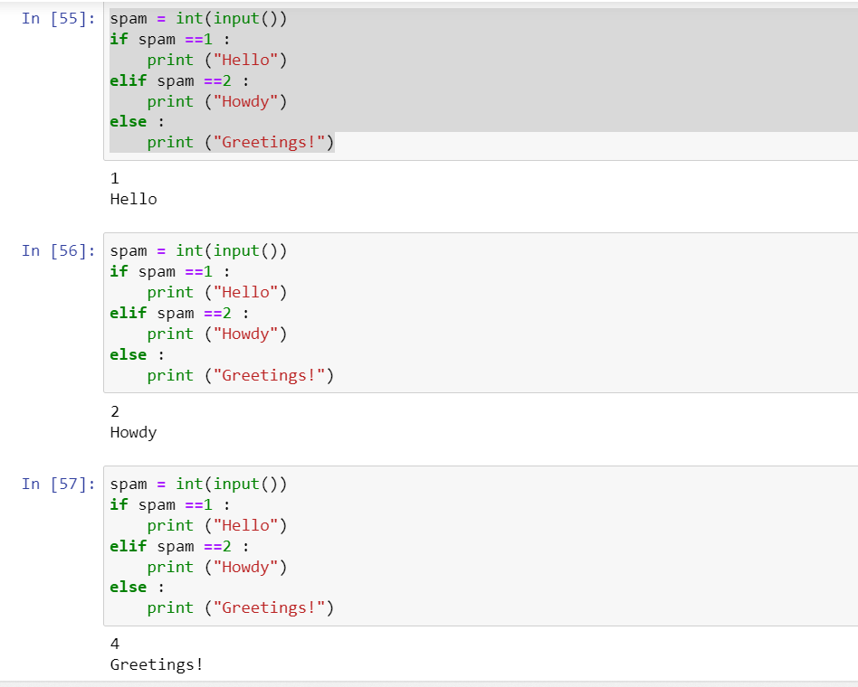

**9.If your programme is stuck in an endless loop, what keys you’ll press?**

Press Interrupt the kernel icon to exit from a infinite loop

**10. How can you tell the difference between break and continue?**

Break Statement is used to “break” a for or while conditional loop. When a specific condition is met, if break statement is used, it will come out or whole loop and executes the next statement written after that loop, if any.

Continue Statement is used to skip code within a loop when a specific condition is met, but unlike break, remaining loop is executed in case of continue.

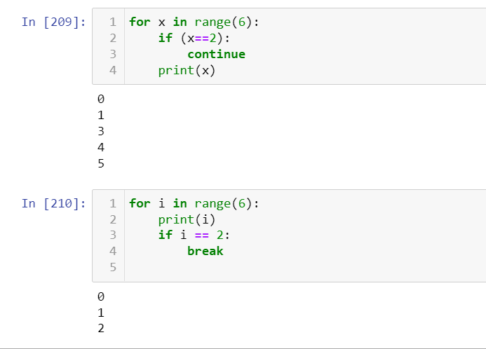

**11. In a for loop, what is the difference between range(10), range(0, 10), and range(0, 10, 1)?**

range(10) -> 10 is the upper bound so if use it in list it will print from 0 to 9 (excluding its upper bound i.e. 10 here)

range (0,10) -> Here we have specified lower and upper bound, so it will start from lower bound i.e. 0 and print till 9(excluding upper bound)

range (0,10,1) -> we have specified the lower bound as 0, upper bound as 10 and step size as 1 so it will start printing from lower bound 0 and go till 9 (excluding upper bound) and step size will be 1

Here output of all three will eb same because we have taken default values for lower bound and step size. PFB the code to understand the difference more clearly.

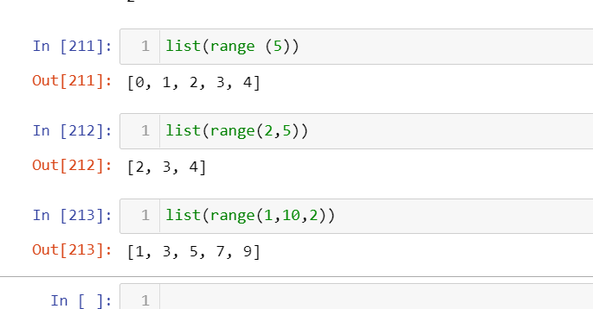

**12. Write a short program that prints the numbers 1 to 10 using a for loop. Then write an equivalent program that prints the numbers 1 to 10 using a while loop.**

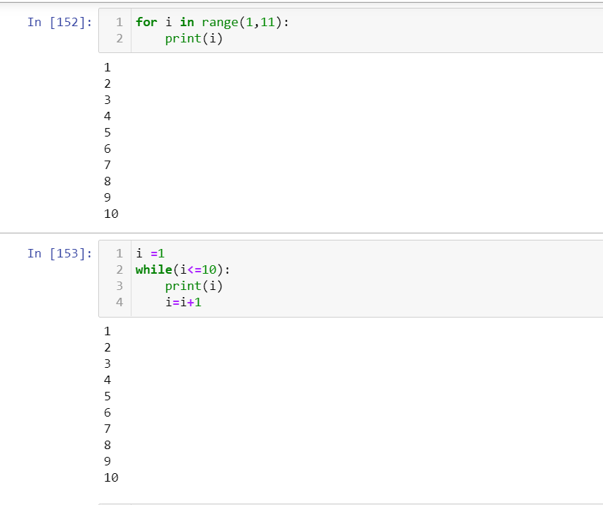

**13. If you had a function named bacon() inside a module named spam, how would you call it after importing spam?**

import spam

spam.bacon()